1410TX

Software Requirements Specification (SRS)

For the

Software

Of

SOQPSK TRANSMITTER

Version: 1.0

Changes Description
Action / Function | Name | Signature | Date
Prepared by
Approved by
SQA
Customer – approved by

Page | Section | Changes | Reference for change
All
All

Scope
The BA-SB-DTX10-V1 is a TELEMETRY TRANSMITTER.
FCM/FM and SOQPSK Transmitter, designed to support a general building clock to multiple projects, this product allows the variety of almost every basic Transmitter parameter and fits to all modulation rates and bandwidth.
The product has two connectors one a RS485 and one RF out channel. The Transmitter receive the SETUP DATA from the RS485 connector, the DATA content a setup mode for the unit according to a code programming on the microchip's controllers and RS485 protocol. And one Frequency channel with SMA adaptor.
The unit controlled by two microcontrollers bulled in, ALTARA'S programmable chip and PIC18 of microchip microcontroller.
- Referenced Documents
  - Standards documents
  - Project documents
No. | identification | Name/Description | Publishing Agency | Revision/Date
1
2
  - Customer Document
No. | identification | Name/Description | Publishing Agency | Revision/Date
1
2

- Hardware Description
  - Fall Unit
Block Diagram of the Fall unit
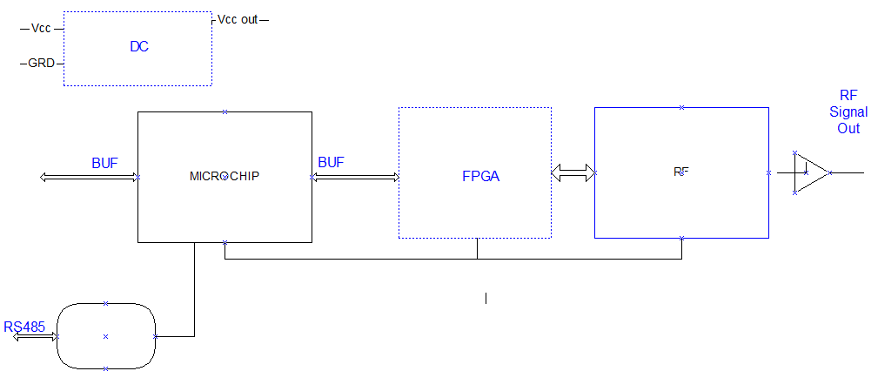
Figure 1 –Fall Unit
  - Setup Data
- Requirements
The transmitter have a variety of controllable definition which the user can change according the need of his setup as mention in System Structure .
- System Structure
Name | code | Expels | Requirement | Remarks
Set Frequency | FR | FR2292.5 | Between 2158.0-2400.0 MHz | Step of 100MHz
Data Source | DS | DS1 | 0 or 1 | 1-Internal 2-External
Data Polarity | DP | DP1 | 0 or 1 | 0-Normal 1-Inverted
Setup SOQPSK | DE | DE1 | 0 or 1 | 0-off 1-on*
Power High | RP | RP0 | 0 or 1 | 0-Low 1-High
Power Command | RF | RF0 | 0 or 1 | 0-Off 1-On
Randomizer | RA | RA0 | 0 or 1 | 0-Off 1-On
Work Mode | MO | MO1 | 0 or 3 | 0-PCM/FM 1-SOQPSK 2-Carrier Only 3-IQ imbalance
Bitrate | IC | IC30.00 | Between 1.00-30.00 DBps | In this form MM.KK
Internal pattern | ID | ID1 | 0 or 3 | 0-always 0 1-always 1 2-PTN15 3-PTN17
Power Level | VP | VP22 | broadcast 22dbm | Value in dbrn
High Power Level | VL | VL25 | 20 or 40
Negative Power Level | VM | VM1 | 0 or 1
Positive Power Level | VC | VC1 | 0 or 1
Clock Phase | CS | CS1 | 0 or 1 | Phase 0-180 degrees
Help | H | H |  | Lest of all commands
Polarety invertible on/off | RB0/RB1 | RB0 | RB0>"AIR"=RF1 "GND"=RF0, RB1>"AIR"=RF0 "GND"=RF1
Polarety invertible low/high | RC0/RC1 | RC0 | RC0> "AIR"=sv "+3V"=VL ,RC1 "AIR"=VL "+3V"=sv
Version | VE | VE |  | Version and model
State | Q | Q |  | All prmeters Satet
Save | SV | SV |  | NO change after on/off
Reset | RE | RE |  | State: Frequncey 2185 Mode PCM/FM RF0
Table 1 – System Structure
* If the transmitter is in Mode 1 (SOQPSK) then it will make a differential encoding
- Communications
Communications between primary pic microcontrollers to a secondary FPGA controller that connected to modulator via D/A convector. The pic also connected to Voltage Controller Oscillator and the VCO to modulator which creates the Frequency the pic18 sent.
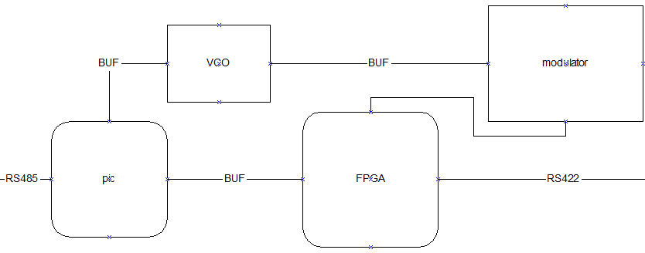
Figure 2- communication

  - Serial Definition
To make the transmitter and receiver UART work together, they must agree on the same values of five parameters:
- Number of bits per character must be declared.
- Bits per second have to be declared.
- If parity is used, both sides must agree on using odd or even parity.
- The number of stop bits must be agreed upon.
Data bits | 8
Bit rate | 115.2 Kbps
Parity | none
Stop bit(s) | 1

  - Protocol

- Bootload Session
- Computer Control

  - Control Unit/ Microcontroller
The microcontrollers (the control unit of the Transmitter) will do the following:
* The microcontroller will include initialize of the system, output level, setup, PLL, A2D and Altera control unit.
* control the Synthesizer The synthesizer should get 4 data-lines from the PIC; Clock, Data, LE, LD. The Synthesizer gets constant setting in power up.
* Each channel has a shutdown mode. This is controlled by one bit for each channel.
Low – the channel is off, High – the channel is on.
* Unit setup Mode:
* Read the temperature status of each channel
- Hardware
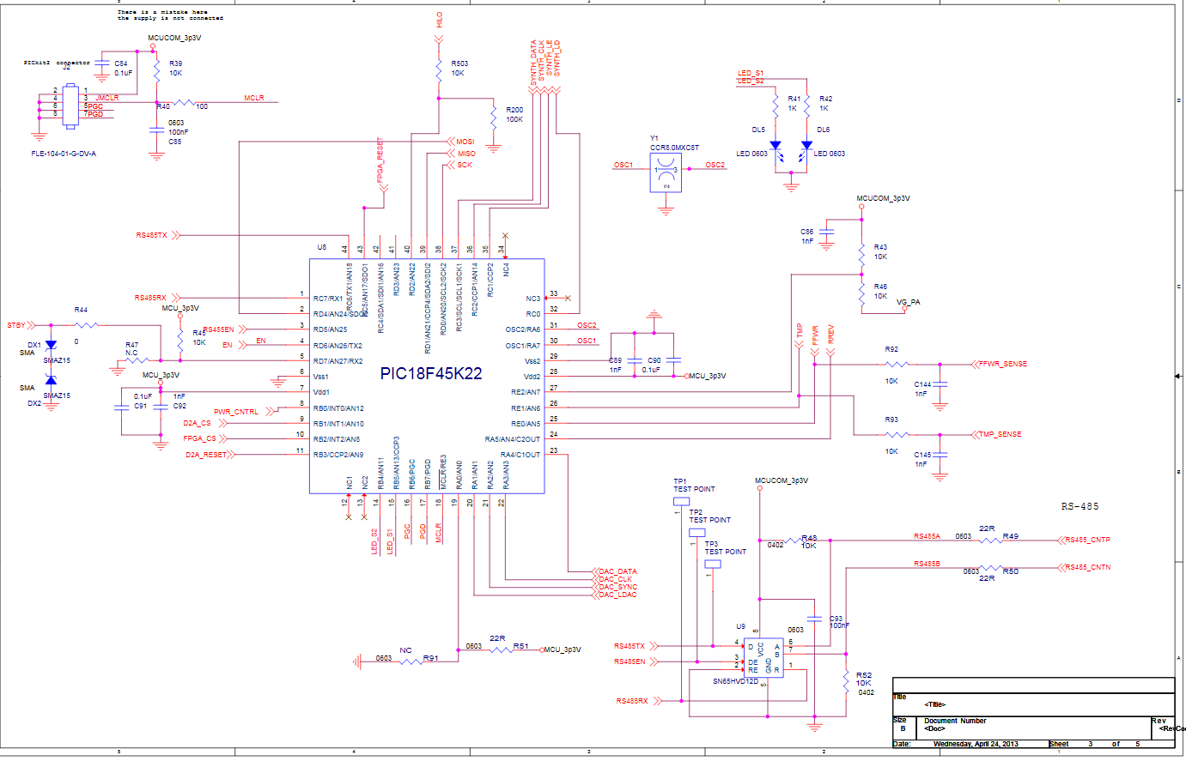

  - Microcontroller
    - General
Selected MCU | PIC18F45K22
Operating voltage | 3.3V
Internal clock | 8MHz
Operating speed | 40MHz (using internal PLL multiplier)

    - Pin Details
The control lines to the PIC are:
 | Name | pins | Format | Description
TOP_LEVEL : PIN_C1 | PLL_LAT | 1 | Analog | Set the broadcast frequency by using PLL
TOP_LEVEL : PIN_C2 | PLL_CLK | 1 | I | Set the broadcast frequency by using PLL
TOP_LEVEL : PIN_C3 | PLL_DAT | 1 | O | Set the broadcast frequency by using PLL
TOP_LEVEL : PIN_C0 | PLL_LD | 1 | I | Set the broadcast frequency by using PLL
TOP_LEVEL : PIN_B2 | CSN | 1 | O | FPGA Control
TOP_LEVEL : PIN_D5 | RS485_EN | 1 | O | RS4858 Control
TOP_LEVEL : PIN_B4 | LED1 | 1 | O | LED
TOP_LEVEL : PIN_B5 | LED2 | 1 | O | LED
TOP_LEVEL : PIN_B3 | D2A_RESET | 1 | I | Reset Digital to Analog
TOP_LEVEL : PIN_B1 | D2A_CSB | 1 | O | Reset Digital to Analog
TOP_LEVEL : PIN_D4 | D2A_MOSI | 1 | I | Reset Digital to Analog
TOP_LEVEL : PIN_D1 | D2A_MISO | 1 | O | Reset Digital to Analog
TOP_LEVEL : PIN_D0 | D2A_SCLK | 1 | O | Reset Digital to Analog
TOP_LEVEL : PIN_D6 | POWER_EN | 1 | I | Set the voltage controllers
TOP_LEVEL : PIN_D2 | HILO | 1 | O
TOP_LEVEL : PIN_D7 | STANDBY | 1 | O
TOP_LEVEL : PIN_A3 | DA2_CLK | 1 | O | AD5312
TOP_LEVEL : PIN_A4 | DA2_DAT | 16 | O | AD5312
TOP_LEVEL : PIN_A2 | DA2_SYN | 1 | O | AD5312
TOP_LEVEL : PIN_A1 | DA2_LAT | 1 | O | AD5312
TOP_LEVEL : PIN_C6 | xmit | 1 | O
TOP_LEVEL : PIN_C7 | rcv | 1 | I
TOP_LEVEL : PIN_A6 | OSC2 | 1 | I | Unit that block the retuning voltage in order to keep the unit from an untied voltage that may damage the unit
TOP_LEVEL : PIN_A7 | OSC1 | 1 | O
TOP_LEVEL : Vss | Vss | 1 | I | Supply for the microcontroller unit
TOP_LEVEL : Vdd | Vdd | 1 | I | Supply for the microcontroller unit
TOP_LEVEL : PIN_C7
TOP_LEVEL : PIN_C7
TOP_LEVEL : PIN_C7
TOP_LEVEL : PIN_A5 | RREV |  |  | Reading the Analog voltage
TOP_LEVEL : PIN_E1 | TMP |  |  | Reading the Analog voltage
TOP_LEVEL : PIN_E0 | FFWR |  |  | Reading the Analog voltage
TOP_LEVEL : PIN_A4 | DAC_DATA |  |  | Control the gate power voltage
TOP_LEVEL : PIN_A3 | DAC_CLK |  |  | Control the gate power voltage
TOP_LEVEL : PIN_A2 | DAC_SYNC |  |  | Control the gate power voltage
TOP_LEVEL : PIN_A1 | DAC_LDAC |  |  | Control the gate power voltage
TOP_LEVEL : PIN_E3 | MCLR | 1 | I | Microcontroller burning pins
TOP_LEVEL : PIN_B7 | PGD | 1 | I | Microcontroller burning pins
TOP_LEVEL : PIN_B6 | PGC | 1 | I | Microcontroller burning pins
TOP_LEVEL : PIN_C7
 | TOTAL CONTROL: | 144

